# Software Requirements Specification (SRS)

**Project Name**: Crafty Corner  
**Prepared By**: Mohamed Ashraf , Habib Ahmed   
**Date**: [11/9/2024]

## 1. Introduction

### 1.1 Purpose

The purpose of this document is to outline the functional and non-functional requirements for Crafty Corner, a website that sells clothing designed by the company itself, as well as handmade works sourced from independent creators. This document will serve as a guide for developers, testers, and other stakeholders involved in the project.

### 1.2 Scope

The Crafty Corner system will be an e-commerce platform that allows users to purchase clothing and handmade items. It will allow independent creators to submit their handmade works for sale. The system will provide functionality for:

* Browsing and purchasing clothing and handmade items.
* Allowing independent creators to submit and manage their handmade items on the platform.
* Managing user accounts for both customers and creators.

### 1.3 Definitions, Acronyms, and Abbreviations

* **API:** Application Programming Interface
* **UAT:** User Acceptance Testing
* **CMS:** Content Management System
* SSL: Secure Socket Layer

### 1.4 References

* **Reference 1:** <https://www.bigcommerce.com/articles/ecommerce/best-practices/>
* **Reference 2:** Crafty Corner Brand Guidelines

## 2. System Overview

### 2.1 Product Perspective

The Crafty Corner system is a standalone e-commerce platform. It interacts with payment gateways [credit cards, Cash on delivery (COD)] for handling transactions and supports integrations with social media for marketing purposes. It consists of:

* **Frontend:** The user interface for customers and creators to interact with the platform, including browsing products and submitting handmade works.
* **Backend:** Server-side logic for processing transactions, managing inventory, and handling creator submissions.
* **Database:** Stores user information, product listings, order history, and transaction records.

### 2.2 Product Functions

The key functions of the system include:

### Product Browsing and Search: Allows users to search and filter products by categories such as clothing, handmade items, price, and more.

### Shopping Cart and Checkout: Users can add items to their cart and proceed through a secure checkout process.

### Creator Portal: Independent creators can submit their handmade works, manage inventory, and track sales.

### User Accounts: Customers and creators can register, log in, and manage their personal profiles.

### Order Management: Customers can view order history, track shipments, and manage returns.

### 2.3 User Classes and Characteristics

Different types of users who will interact with the system include:

* **Admin Users:** Full access to all system functions, including user management, product listing approval, and site configuration.
* **Customers:** Can browse, purchase, and review products.
* **Creators**: Independent artisans who can upload, manage, and sell their handmade items through the platform.
* **Guest Users:** Can browse products but need to register to make purchases or submit items.

### 2.4 Operating Environment

The system will operate in the following environments:

* **Client Side**: Runs on web browsers like Chrome, Firefox, Edge, and Safari.
* **Server Side**: Hosted on a cloud server using Linux with Node.js for backend services.
* **Database**: Uses MySQL for data storage and management.

## 3. Functional Requirements

### 3.1 Use Case Diagrams / User Stories

* **Use Case 1**: **User Purchases Product**
  + **Description**: A customer selects items to purchase, adds them to the shopping cart, and completes the checkout process.
  + **Actors**: Customers, Website (Crafty corner)
  + **Preconditions**: The customer has an account and is logged in.
  + **Postconditions**: The order is confirmed, and the customer receives an order confirmation email.
  + **Steps**:
    1. User selects items and adds them to the shopping cart.
    2. User reviews items in the cart and proceeds to checkout.
    3. User enters payment and shipping information.
* **Use Case 2**: **Seller’s product submitting** 
  + **Description**: This use case outlines the steps a seller takes to submit a new product for sale on the Crafty Corner website and he can upload and set the prices for his products.
  + **Actors**: Seller, Website (Crafty Corner), Admin.
  + **Preconditions**: The seller must have an account on the "Crafty Corner" website and be logged in and the seller must have a product ready to be submitted.
  + **Postconditions**: The seller's product is successfully submitted for review and the admin is notified of the new product submission.
  + **Steps**:
    - 1. The seller logs into his account.
      2. The seller accesses the seller’s dashboard on the website.
      3. The seller uploads his products and set their prices.
      4. The seller submits his products for review.
      5. Then the products are confirmed and approved by the admin.

### 3.2 Feature Requirements

#### Feature 1: Product Search and Filter

* **Description**: Users can search for products by category, keyword, and price range.
* **Inputs**: Search queries, filters.
* **Outputs**: Display of matching products.
* **Error Handling**: If no products match the search criteria, show a "No results found" message.

#### Feature 2: Creator Submission Portal

* **Description**: Creators can upload images and descriptions of handmade products they want to sell.
* **Inputs**: Product details, images, pricing.
* **Outputs**: Pending approval status.
* **Error Handling**: Notify the creator if any required fields are missing.

## 4. Non-Functional Requirements

### 4.1 Performance Requirements

* The system should respond to user requests within 2 seconds for most interactions.

### It must support up to 250 concurrent users without significant degradation in performance.

### 4.2 Security Requirements

* User data, including personal and payment information, must be encrypted in transit and at rest using SSL.
* Only authorized users (creators, admins) should have access to upload or manage products.

### 4.3 Usability Requirements

* The user interface must be intuitive, with clear navigation for both customers and creators.
* Accessibility features should support users with disabilities in compliance with WCAG 2.1 guidelines.

### 4.4 Reliability and Availability Requirements

* The system must have 99.9% uptime.
* In the event of a failure, the system should recover and resume operations within 5 minutes.

### 4.5 Scalability

### The system should scale to handle up to 800 registered users and 350 product listings.

### 4.6 Compatibility

* The system should work seamlessly on modern web browsers (Chrome, Firefox, Edge, Safari)
* The system should be compatible with mobile devices.

## 5. System Models

### 5.1 Use Case Diagrams

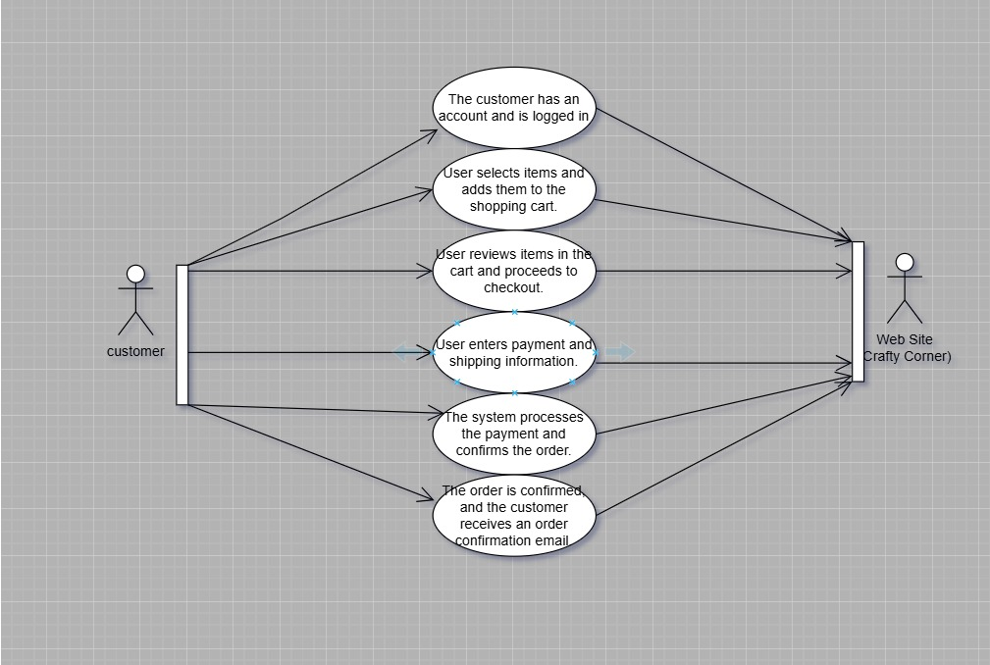

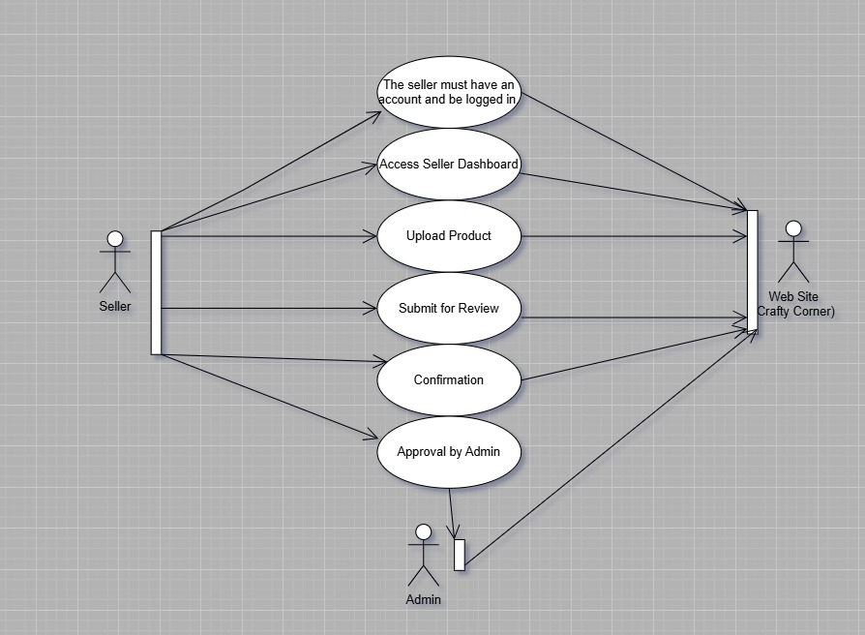

### 5.2 Data Flow Diagrams

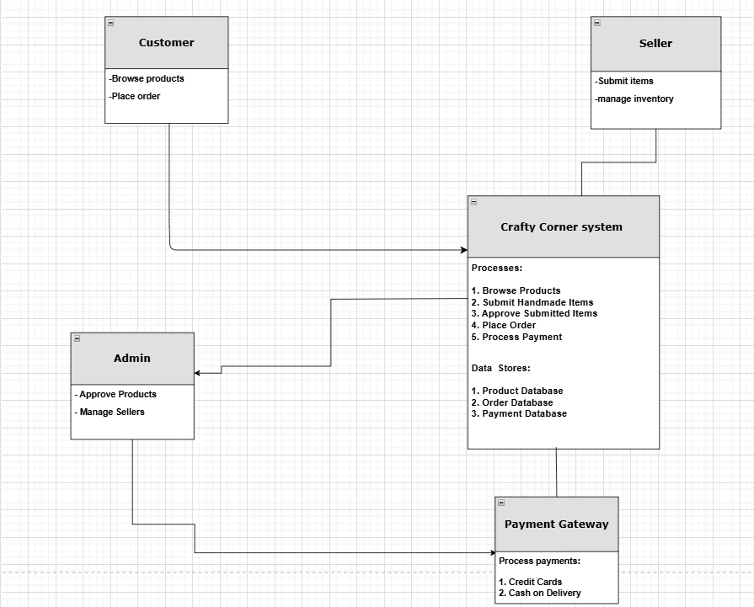

### 5.3 Class Diagrams

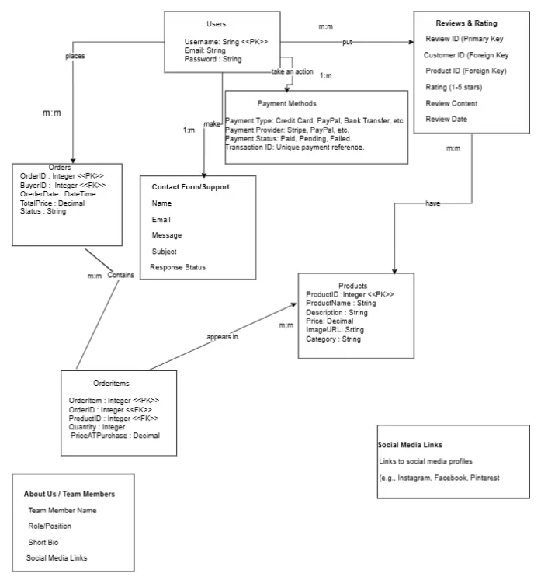

## 6. External Interface Requirements

### 6.1 User Interfaces

* The system should have an intuitive UI with the following major components:

1. **Home Screen:** Displays featured products and categories.
2. **Dashboard:** Allows users to manage their accounts, view orders, and track submissions (for creators).
3. **Search Bar:** Allow the user to search for the products he wants.
4. **Settings icon:** It contains user account center, customer service

### 6.2 API Interfaces

* The system will provide APIs for data retrieval, user management, and order processing.
* APIs will follow the REST protocol.

### 6.3 Hardware Interfaces

* The system will interact with serial number for each product for helping in management products.

## 7. Other Requirements

### 7.1 Legal and Regulatory Requirements

### The system must comply with GDPR(General Data Protection Regulation) regarding user data protection.

### 7.2 Documentation Requirements

### Provide user manuals for customers and creators, along with API documentation for developers.

### 7.3 Data Backup Requirements

* The system should back up data every week and store backups for 30 days.

## 8. Conclusion

This SRS document outlines the functional and non-functional requirements for Crafty Corner. By following these specifications, the development team will create a system that meets the expectations of customers, creators, and other stakeholders.